1. **Identifying the systematic design process to be followed.**

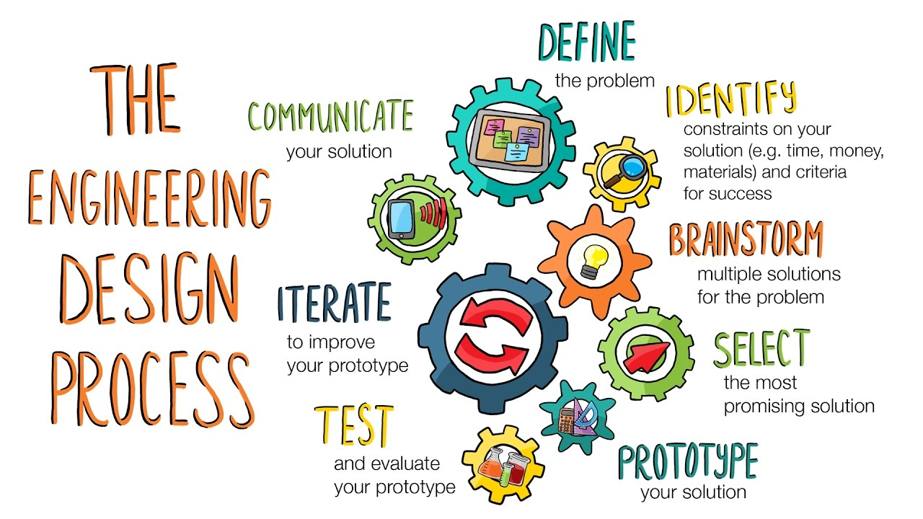

Figure 3: Engineering Design Process

The ***engineering design process*** is a methodical series of steps that engineers follow to come up with a solution to a problem. It is typically an iterative process, with designers making multiple prototypes and refining their designs based on feedback and testing.

The engineering design process also helps to foster creativity and innovation. By following a structured process, engineers can generate a wide range of potential solutions and evaluate them based on their feasibility and potential impact. This allows engineers to come up with creative and novel solutions that may not have been considered otherwise.

Additionally, the engineering design process helps to ensure that solutions are safe, ethical, and sustainable. Throughout the design process, engineers consider safety, environmental, and ethical considerations to ensure that the final solution is not only effective, but also responsible and sustainable.

Some key benefits of using the engineering design process include:

1. Improved problem-solving skills: The engineering design process encourages critical thinking and creativity, helping engineers to develop better problem-solving skills.
2. More efficient and effective solutions: By following a structured approach, engineers can generate a wide range of potential solutions and evaluate them based on specific criteria, ensuring that the chosen solution is the most effective and efficient.
3. Enhanced communication and collaboration: The engineering design process promotes collaboration among team members and encourages clear communication, helping to ensure that all stakeholders are on the same page and working towards a common goal.
4. Better decision-making: The engineering design process provides a systematic approach for evaluating potential solutions and making informed decisions, leading to better outcomes and improved project success.

The steps in the engineering design process typically include:

1. Define the problem: The first step in the engineering design process is to clearly define the problem or challenge that needs to be addressed. This involves identifying the specific needs and requirements of the project, as well as any constraints or limitations.
2. Generate potential solutions: Once the problem has been defined, the next step is to generate a range of potential solutions that could address the problem. This may involve brainstorming sessions, research, or other forms of idea generation.
3. Evaluate potential solutions: The next step is to evaluate the potential solutions based on specific criteria and constraints. This may involve conducting research, testing prototypes, or using mathematical or computational modelling to evaluate the feasibility and effectiveness of each solution.
4. Select the most appropriate solution: After evaluating the potential solutions, the next step is to select the most appropriate solution based on the criteria and constraints. This decision may be made by the team, or it may involve consultation with stakeholders or other experts.
5. Develop a plan: Once the solution has been selected, the next step is to develop a plan for implementing the solution. This may involve creating detailed design drawings, specifications, and other documents that outline the steps and resources needed to implement the solution.
6. Implement and test the solution: The final step in the engineering design process is to implement and test the chosen solution. This may involve building and testing prototypes, conducting experiments, or conducting other forms of validation to ensure that the solution meets the needs and requirements of the project.

General Flow of Engineering Design Process:

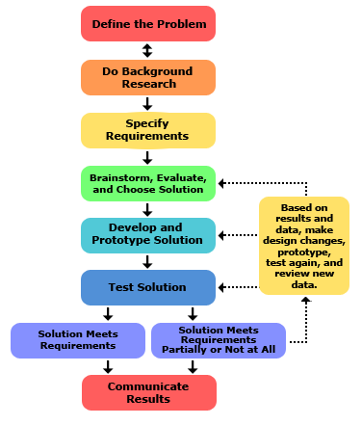

Figure 4: Flow of Engineering Design Process

Overall, the engineering design process is an important tool for engineers to systematically and effectively solve problems. It allows designers to systematically explore a variety of solutions, test their feasibility and effectiveness, and ultimately create a final design that meets the needs of the problem.